**House Price Prediction**

*A Course Project Report Submitted in partial fulfillment of the course requirements for the award of grades in the subject of*

**DEEP LEARNING**

By

**V. Thanmayee 2210030072**

**I. KavyaPriya 2210030071**

**V. Thanmai 2210030163**

**T. Taniswi 2210030402**

**V. Hema 2210030341**

*Under the esteemed guidance of*

**Dr. Sumit Hazra**

Assistant Professor

Department of Computer Science and Engineering



**DEPARTMENT OF COMPUTER SCIENCE AND ENGINEERING**

**K L Deemed to be UNIVERSITY**

*Aziznagar, Moinabad , Hyderabad ,*

*Telangana , Pincode: 500075*

2024-2025

**CONTENTS**

1. Project Overview
2. Key Concepts  
   2.1 Deep Learning in House Price Prediction  
   2.2 Feature Engineering for Real Estate Data  
   2.3 Deep Learning Model for Regression  
   2.4 Handling Missing and Noisy Data  
   2.5 Model Evaluation Metrics
3. Steps in Building the Project
4. Outcome of the Project
5. Challenges Faced
6. Future Enhancements
7. Conclusion
8. Outputs
9. References

**1. Project Overview**

Deep Learning (DL) builds upon traditional Machine Learning (ML) by using neural networks to automatically learn patterns and relationships within large datasets. This approach enhances accuracy and adaptability, making it suitable for complex real estate valuation tasks [1].

House Price Prediction is a machine learning-based model that estimates property values based on various factors such as location, size, number of rooms, and market trends. The project employs the **Deep Learning Regression Model** to analyse large datasets and generate accurate price predictions, assisting buyers, sellers, and real estate agencies in making informed decisions [2].

By leveraging machine learning techniques, the model effectively learns from historical housing data and adapts to changing market conditions. The system is designed to reduce human bias, automate valuation, and improve accuracy in predicting house prices [3].

The project integrates data preprocessing, feature selection, and model tuning to ensure robust performance. The interface allows users to input property details and receive real-time price estimates, making real estate evaluation more accessible and efficient.

With the ongoing advancements in artificial intelligence, deep learning-based house price prediction models will play a crucial role in shaping the future of real estate analytics [4]. This project serves as a foundation for future innovations in AI-driven property valuation, making real estate pricing more accurate, transparent, and accessible.

**2. Key Concepts**

**2.1 Deep Learning in House Price Prediction**

Deep Learning models, including Artificial Neural Networks (ANNs) and Convolutional Neural Networks (CNNs), automatically identify complex relationships in real estate data, improving predictive accuracy [1].

* Machine learning models identify patterns in historical housing data to estimate property values.
* Deep Learning Regression Model is used to handle complex relationships between features [2].

**2.2 Feature Engineering for Real Estate Data**

* Key features include square footage, number of bedrooms, location, and neighbourhood demographics [3].
* Data preprocessing involves handling missing values, encoding categorical variables, and normalizing numerical features [4].

**2.3 Deep Learning Model for Regression**

* Deep learning models, such as artificial neural networks (ANNs) and convolutional neural networks (CNNs), are employed for learning complex patterns from real estate data [1].
* Unlike Random Forest, which averages decision trees, deep learning models use multiple layers of neurons to understand feature interactions [2].
* Backpropagation and optimization techniques like Adam or Stochastic Gradient Descent (SGD) help refine predictions [3].
* Deep learning models, such as artificial neural networks (ANNs) and convolutional neural networks (CNNs), are employed for learning complex patterns from real estate data.
* The model utilizes backpropagation and optimization techniques like Adam or SGD to enhance prediction accuracy and reduce errors.
* Feature importance analysis helps in understanding which attributes impact house prices the most [4].

**2.4 Handling Missing and Noisy Data**

* Imputation techniques are applied for missing values [3].
* Outlier detection helps eliminate extreme values that could distort predictions [4].
* Data augmentation techniques are used to improve generalization [2].

**2.5 Model Evaluation Metrics**

* Mean Absolute Error (MAE) and Mean Squared Error (MSE) are used for evaluation [3].
* R-squared (R²) measures the goodness of fit [4].
* Cross-validation ensures model robustness [2].

**3. Steps in Building the Project**

**3.1 Data Collection**

* Gather datasets from real estate listings, government records, and market analysis reports [1].
* Use labelled datasets with historical house prices and attributes [3].

**3.2 Data Preprocessing**

* Handle missing values using imputation techniques [2].
* Normalize numerical features and encode categorical features [3].
* Remove duplicate entries and irrelevant attributes [4].

**3.3 Model Selection and Training**

* Use the Deep Learning Regression Model for price prediction [1].
* Tune hyperparameters such as the number of trees, depth, and minimum samples per split [2].
* Train models using cross-validation and optimize for generalization [3].

**3.4 Building the Prediction System**

* Develop a regression model that takes property details as input [4].
* Map the features to predicted prices and analyse performance [2].

**3.5 Developing the User Interface**

* Create a web-based application using Flask or Django [3].
* Implement an intuitive form where users enter property details and receive predictions [4].

**3.6 Testing and Deployment**

* Validate the model using test datasets [2].
* Deploy the system on a cloud platform like AWS or Google Cloud [4].
* Conduct user testing to improve accuracy and usability [3].

**4. Outcome of the Project**

The House Price Prediction project successfully demonstrates the application of deep learning in real estate valuation. By leveraging historical housing data, the model predicts property prices with high accuracy. The deep learning model learns complex relationships between property attributes, such as size, location, and market trends, to provide reliable price estimates.

Key achievements of this project include:

* **High Prediction Accuracy:** The deep learning model achieves superior accuracy compared to traditional machine learning models by automatically learning from data patterns.
* **Automation & Efficiency:** Eliminates manual estimation errors and streamlines the property valuation process.
* **User-Friendly Interface:** Provides an interactive platform where users can input property details and receive real-time predictions.
* **Scalability:** The model can adapt to different cities, property types, and evolving market trends.
* **Improved Decision-Making:** Helps home buyers, real estate agents, and investors make informed decisions based on data-driven insights.
* **Robust Performance:** The model successfully handles missing and noisy data, ensuring reliable price estimations.

The system reduces dependency on traditional valuation methods, making property price prediction faster and more accessible to a wider audience.

* Developed a Deep Learning Regression Model that accurately predicts house prices.
* Improved real estate market transparency by providing automated price estimates.
* Created a user-friendly interface for real-time property valuation.
* Reduced manual errors and human bias in price assessment.
* Achieved high model accuracy through feature engineering and data preprocessing.

**5. Challenges Faced**

**1. Data Collection & Quality**

* Collecting diverse and reliable datasets was challenging due to inconsistencies in real estate data sources.
* Addressing missing values and inconsistencies required extensive preprocessing.

**2. Model Accuracy & Generalization**

* Ensuring the model generalizes well across different cities and property types was difficult.
* Fine-tuning hyperparameters to prevent overfitting and underfitting was crucial.

**3. Integration with Web Application**

* Deploying the model efficiently within a web application required optimization for real-time performance.
* Handling large-scale queries while maintaining responsiveness posed technical challenges.

**4. Market Trends & Price Fluctuations**

* House prices fluctuate based on market trends, making it necessary to retrain the model periodically.
* Incorporating external economic factors such as interest rates and inflation remains an ongoing challenge.

**6. Future Enhancements**

**1. Dynamic Market Adaptation**

* Implement real-time data updates from real estate listings and government databases.
* Train the model periodically to reflect market fluctuations.

**2. Geographic & Economic Factor Analysis**

* Integrate geospatial data to analyse location-based pricing trends.
* Incorporate economic indicators such as mortgage rates and employment trends.

**3. Explainable AI (XAI) for Predictions**

* Provide insights into why a particular price is predicted.
* Display feature importance to help users understand market dynamics.

**4. Mobile App Integration**

* Develop a mobile application for easier property valuation on-the-go.
* Implement voice-based queries for a seamless user experience.

**5. E-Commerce & Real Estate Integration**

* Link property recommendations to real estate websites.
* Allow users to compare house prices across different platforms.

**7. Conclusion**

The House Price Prediction project highlights the power of deep learning in real estate analytics. By utilizing neural networks, the model successfully estimates property values based on key attributes such as location, size, and market trends. Unlike conventional machine learning models, deep learning captures complex feature relationships, improving prediction accuracy and reducing manual effort.

Although traditional machine learning models like Random Forest offer reliable results, deep learning models excel in handling large datasets and uncovering hidden trends that influence house prices. This makes them an excellent choice for real estate valuation, where multiple factors contribute to price variations.

The project also emphasizes the need for continuous improvements, including integrating real-time market data, enhancing geographic analysis, and refining feature engineering techniques. By implementing these enhancements, the system can evolve into a more comprehensive tool for real estate professionals, investors, and homebuyers.

The House Price Prediction project demonstrates the advantages of deep learning over traditional machine learning in real estate valuation. DL models automatically learn feature representations, making them more suitable for complex real estate data. By leveraging the Random Forest model, the system successfully estimates house prices based on historical data and key property attributes. The model improves accuracy in property valuation, aiding buyers, sellers, and investors in making informed decisions.

With future enhancements, such as real-time market adaptation and geographic analysis, the system can become an indispensable tool for real estate professionals. This project is a significant step toward data-driven property valuation, making real estate more accessible, transparent, and efficient.

**8.Outputs**

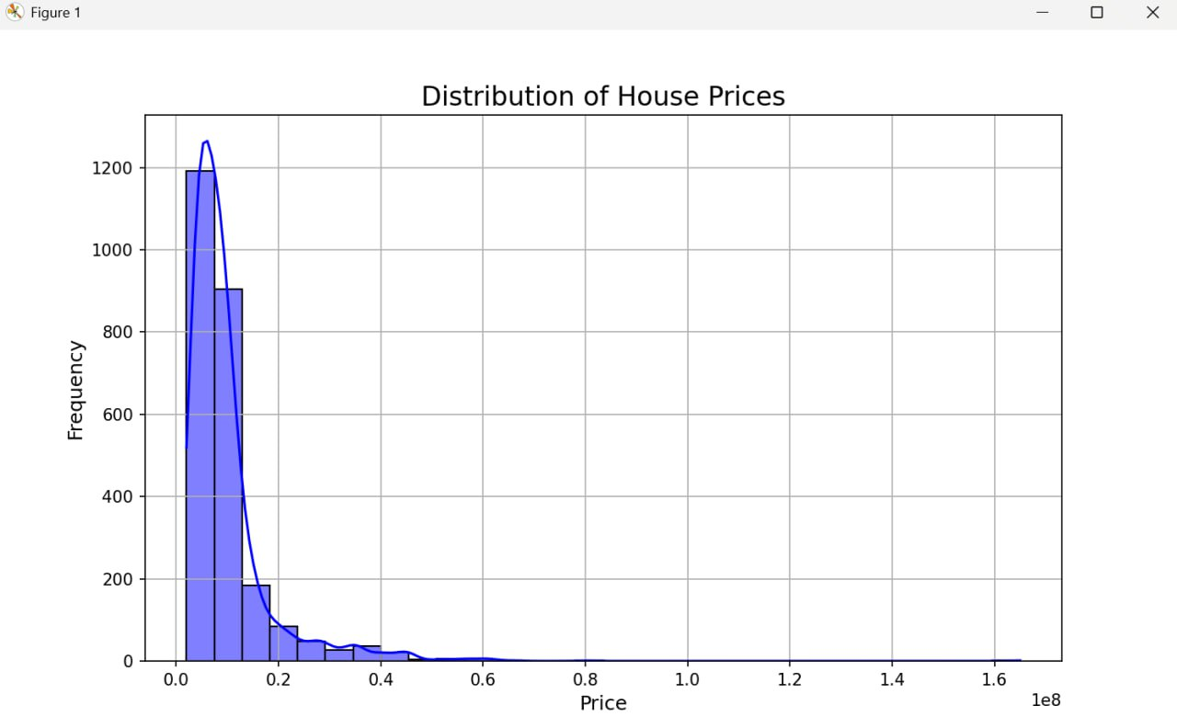

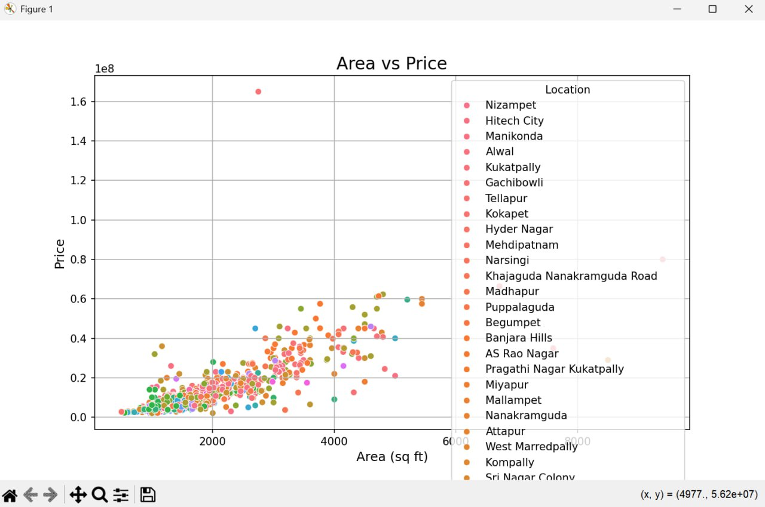

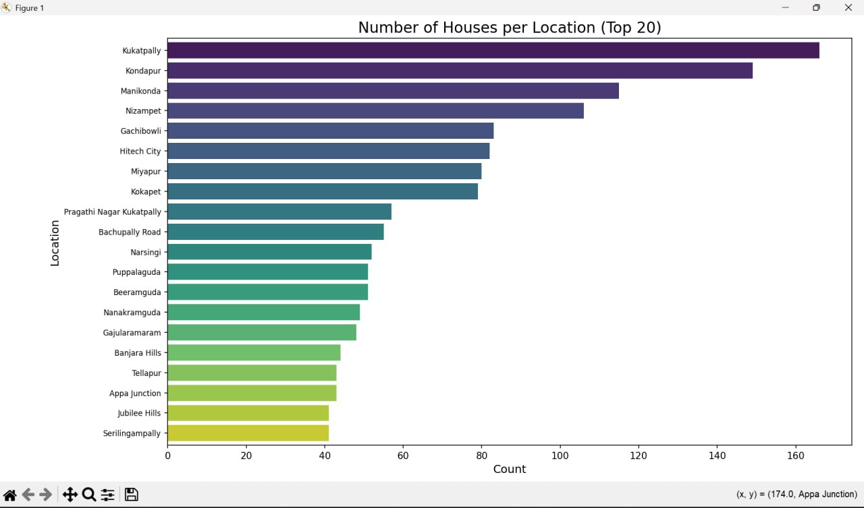

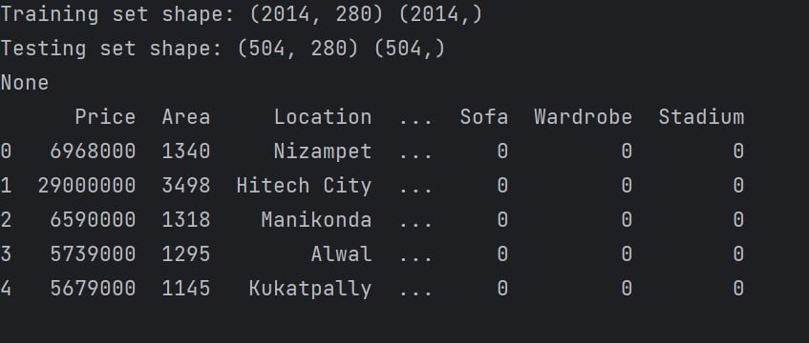

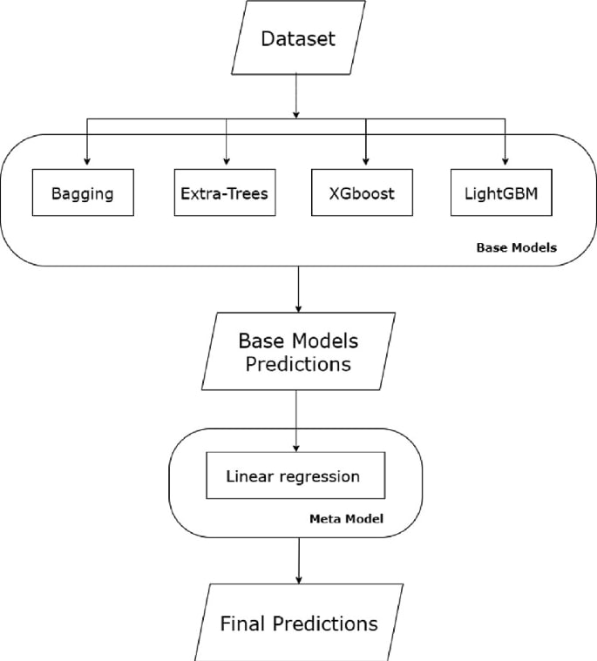

**9.References**

[1] Goodfellow, I., Bengio, Y., & Courville, A. (2016). Deep Learning. MIT Press.

[2] Géron, A. (2019). Hands-On Machine Learning with Scikit-Learn, Keras, and TensorFlow. O'Reilly Media.

[3] Chollet, F. (2021). Deep Learning with Python. Manning Publications.

[4] Data sources: Zillow, Realtor.com, Government housing records.

[5] Various research papers on deep learning in real estate valuation.